

Unearthing the Environmental Impact of Human Activity: A Global CO2 Emission Analysis

April 2023

GUNALAN  
 &

ABDULKALAM  
 HARIKRISHNAN  
 RAKESH  
 JAGADEESH

**Contents**

INTRODUCTION  
  
* Overview A brief description about your project  
 * Purpose of this project.   
  
 Problem Definition & Design Thinking   
 *Empathy Map   
*Ideation & Brainstorming  
  
 RESULT   
* Final findings (Output) of the project .  
  
 ADVANTAGES & DISADVANTAGES  
* List of advantages and disadvantages of the proposed solution   
  
APPLICATIONS   
* The areas where this solution can be applied

FUTURE SCOPE   
* Enhancements that can be made in the future.

\***PROJECT DESCRIPTION\***

* INTRODUCTION  
  **Global warming is one of the biggest challenges currently being faced by the human race, although correlation is not causation, a likely cause of global warming is due to increased atmospheric carbon dioxide from human activities. CO2 Emission refers to the Carbon Dioxide emitted throughout the world. For this analysis we will be focusing on CO2 Emissions and its effect on the world we live in as well as some key factors and stats that may play a role in the emission of CO2 globally. Fossil fuel use is the primary source of CO2. The data throws light onto how much fossil fuels are burnt, per year per nation, which amounts to an increase in CO2 every year. This will help researchers and environment experts to predict global warming. So countries should set a goal to decrease this amount yearly**.
* Overview A brief description about your project  
    
  **The business requirements for analysing the Co2 Emission Globally over time, identifying affecting factors, creating interactive dashboards and reports, identifying areas for improvement, making data-driven decisions, comparing to countries average and creating forecasting models for future performance. The ultimate goal is to gain insights and reduce the emission through data visualization techniques.**
* Purpose of this project  
    
  **In the context of analyzing the Global Co2 Emission, a literature survey would involve reviewing studies and articles that have been published on the topic of Emission, as well as studies specific to Co2.The literature survey would include sources such as academic journals, industry reports, and online articles. It would aim to identify different internal and external factors that are responsible and commonly used to determine Co2 Emission, as well as any best practices or strategies that have been identified for reducing emission.The literature survey would also explore any existing research on Co2 Emission specifically, and would aim to identify any challenges or opportunities that the Countries can opt to reduce emission.**

* Problem Definition & Design Thinking*

Empathy Map

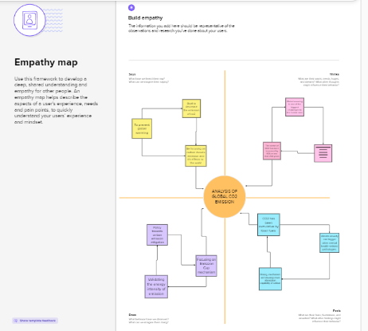

Ideation & Brainstorming Map  
 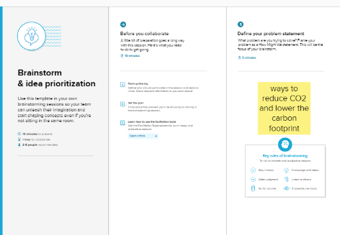

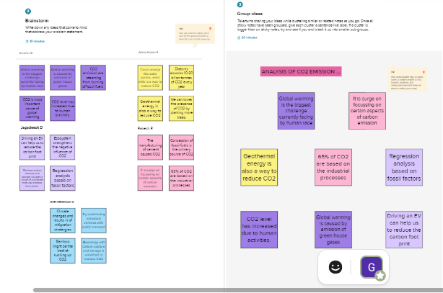

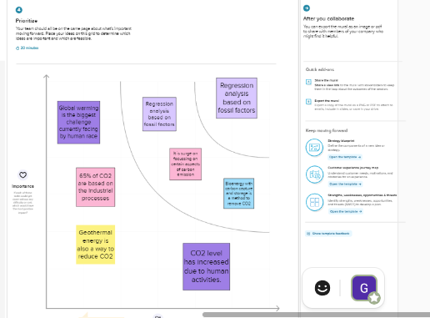

**\*RESULT*  
  
Data Collection & Extraction from Database**

The various activities of this milestone are explained as follows.   
 The amount of data that is rendered to a database depends on the size of the dataset and the capacity of the database to store and retrieve data.

Open the MySQL Workbench, go to the database then click to expand the tables,select the table and click on (i) button to get the information related to table such as column count,table rows etc  


**Downloading The Dataset using link url**   
data Firstly, we narrowed down the search and have downloaded the url of the which provide the basis of the data collection. The data collected had listed below**.**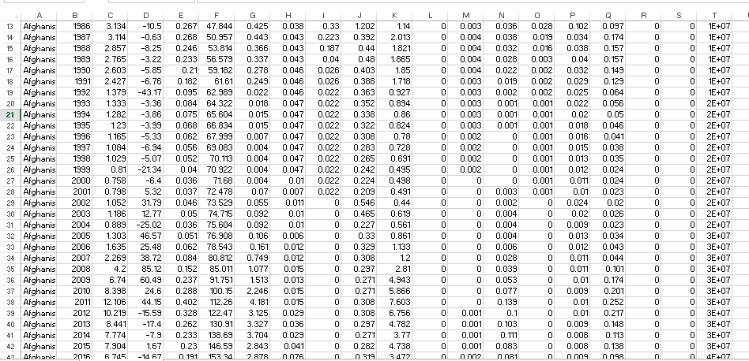

**Column Description of The Dataset**The data collected was based on the type of Co2 emission in country , years etc..along with per capita population. These are listed as mentioned below.   
 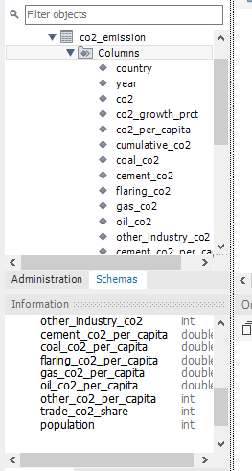

**Storing Data in DB & Perform SQL Operations**In databases, information is stored in tables, columns, and rows for easy processing. A relational database is generally said to be the most common kind

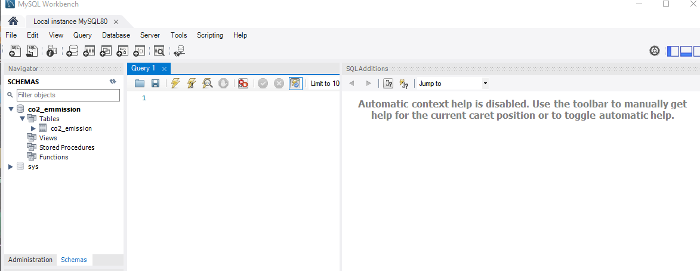

**Connect DB With Tableau**

This is carried out by identifying the Tableau Catalogue which is available with Data Management in Tableau Server and Tableau Cloud. in addition to connecting to published data sources from Tableau Server or Tableau Cloud, the team connected to the databases and tables from the Search for Data results on Tableau Desktop. Data Management included virtual connections, a central access point to data. These are illustrated in the set of diagrams as below

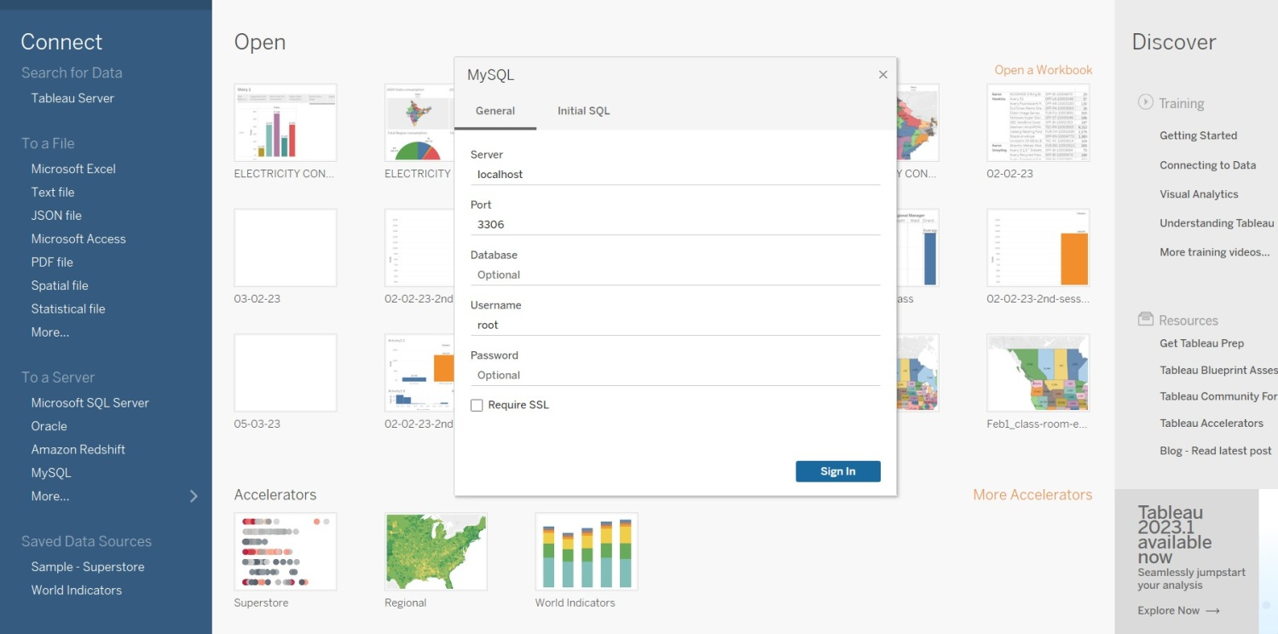

**Data Preparation**

**No of Visualizations/ Graphs**

1.Top World Emission  
2. Top Emitting Countries  
3. Co2 Emission over Time  
4. Co2 Emission India vs USA   
5. Total Emission by Continents   
6. Co2 Emission per Capita  
7. Emission rate by internal factors  
8 Donut chart for cement co2   
9. Donut chart for flaring co2  
10. Donut chart for gas co2  
11. Donut chart for other industry  
12. Co2 emission over past 10 years  
13. Overall contribution by india in co2  
14. Continent wise contribution by internal factors  
15. China vs india internal factors

1. Total world emission   
 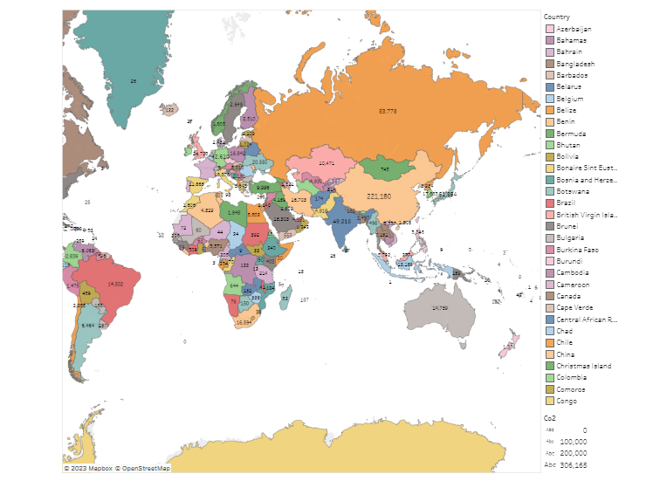  
 2. Top Countries emission

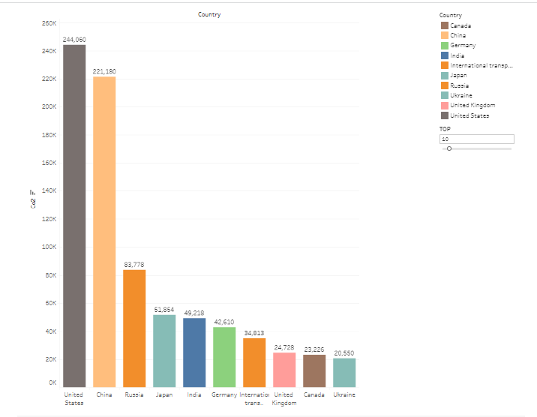

3. CO2 Emission over time

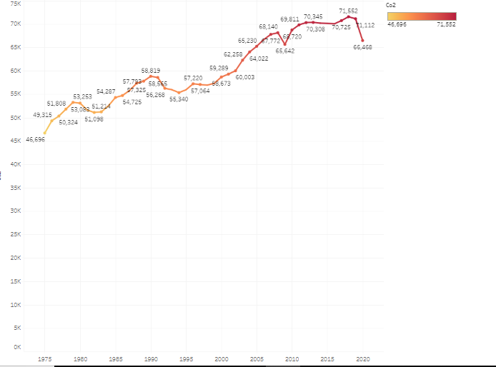

4.CO2 Emission India vs United states

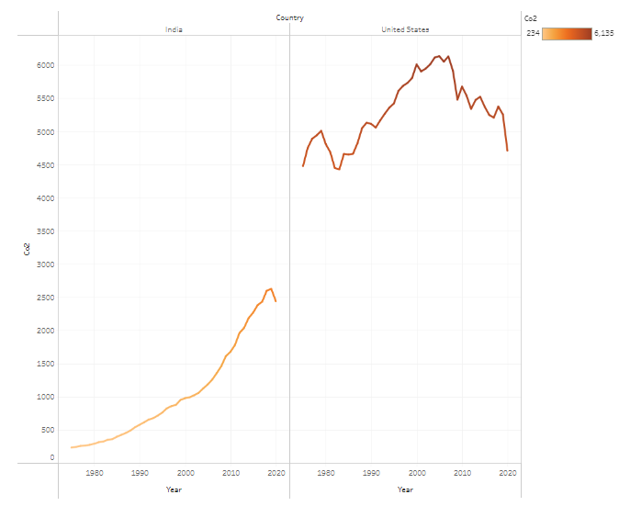

5. Total Emission by Continents

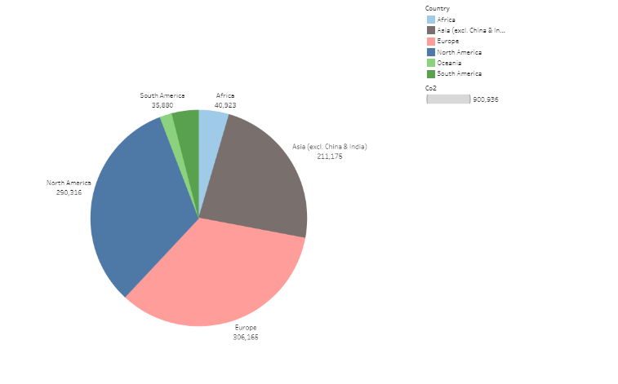

6.CO2 Emission per Capita

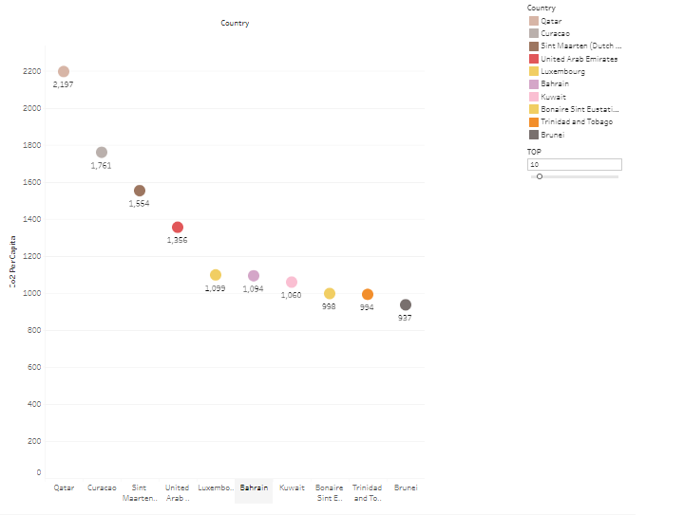

7.EMISSION RATE BY INTERNAL FACTORS

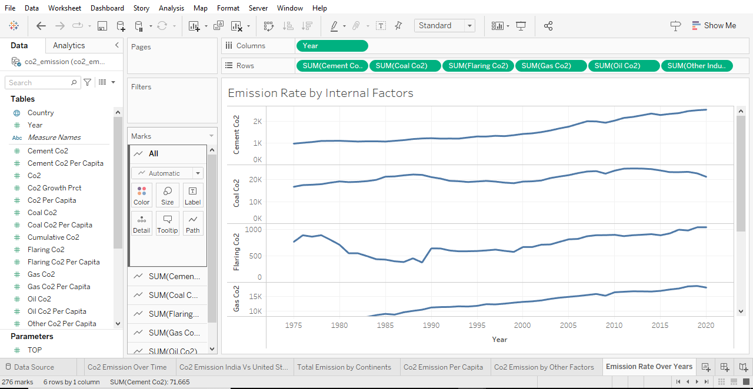

8.DONUT CHART FOR CEMENT CO2

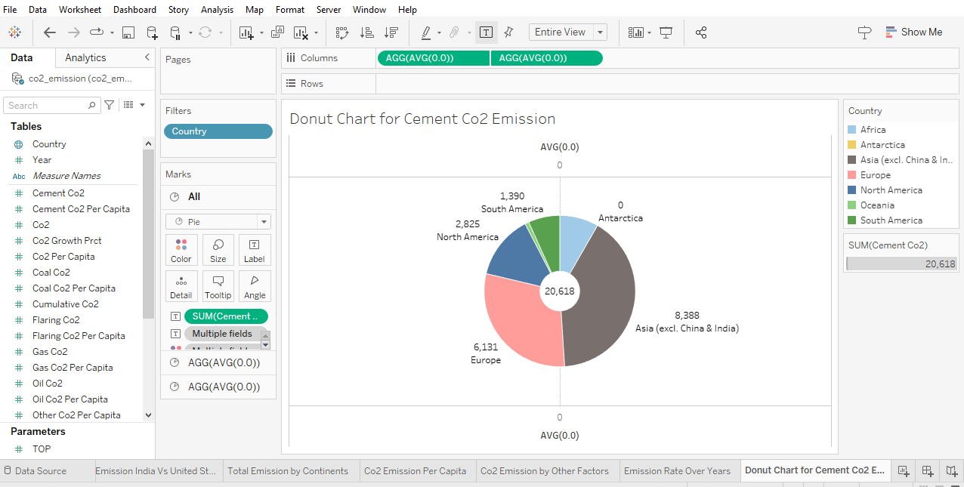

9. DONUT CHART FOR FLARING CO2

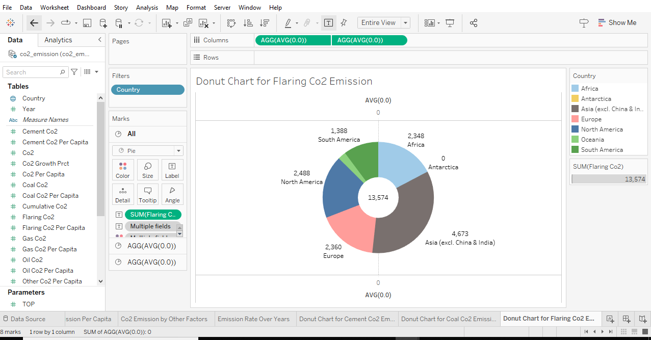

10.DONUT CHART FOR GAS CO2

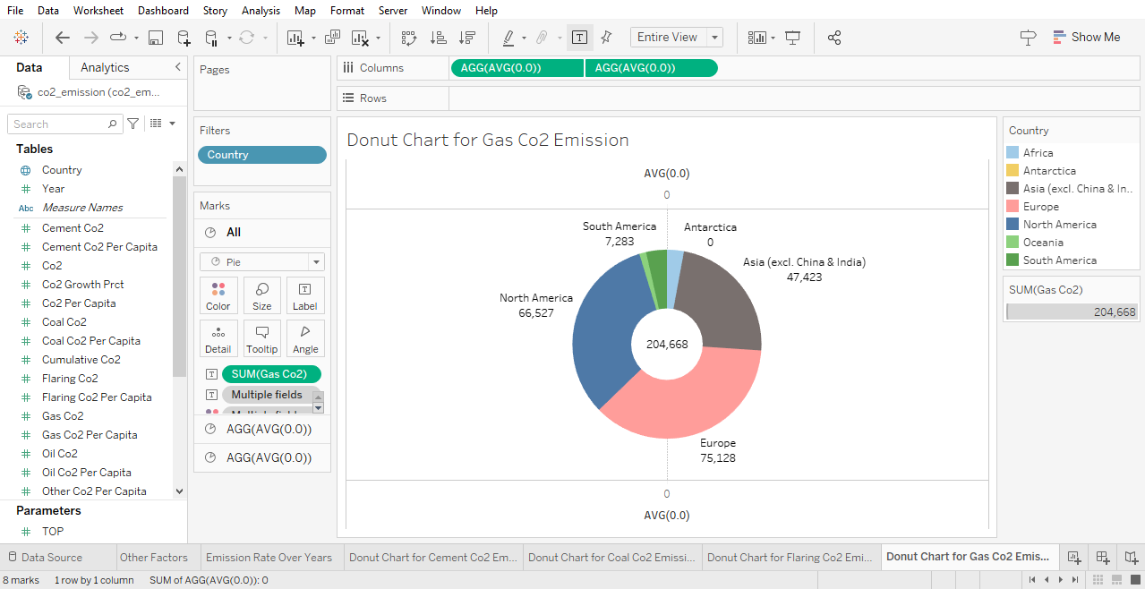

11.DONUT CHART FOR OTHER INDUSTRY

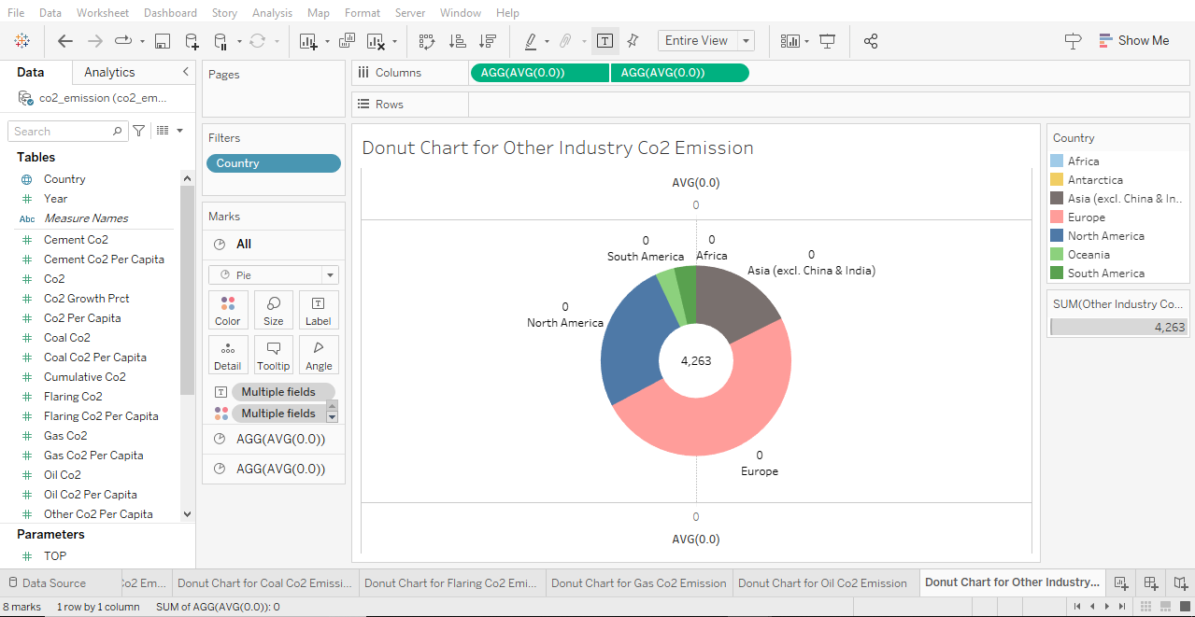

12.CO2 EMISSION OVER PAST 10 YEARS

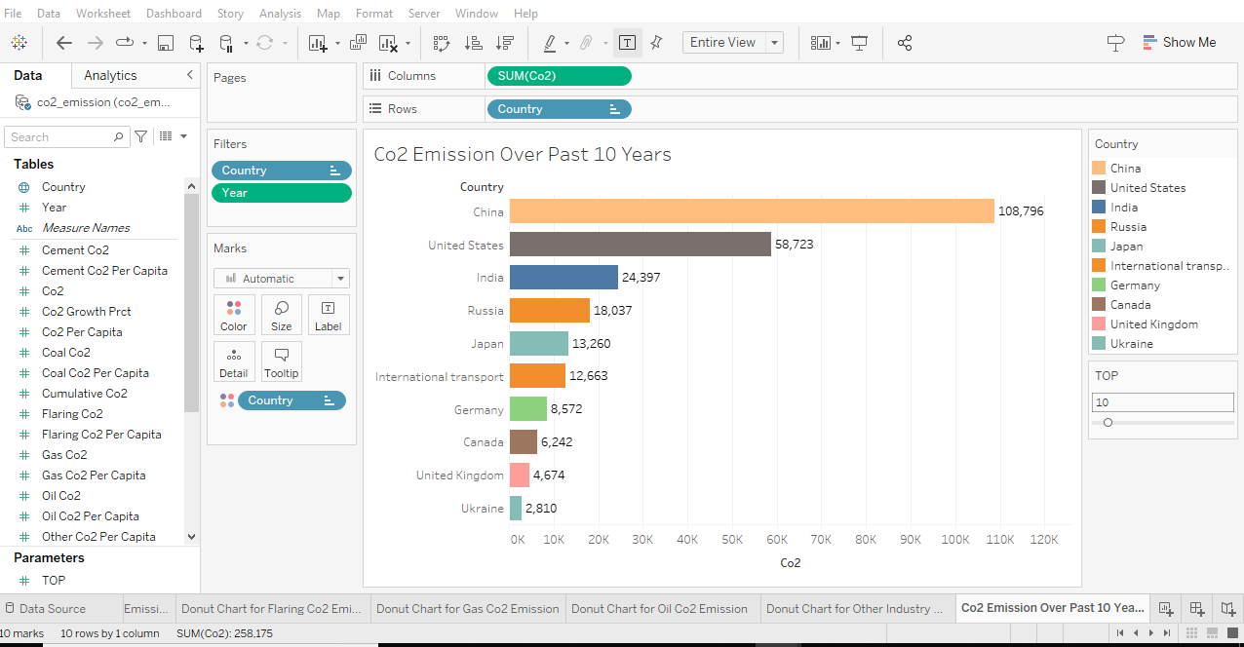

13. OVERALL CONTRIBUTION BY INDIA IN CO2

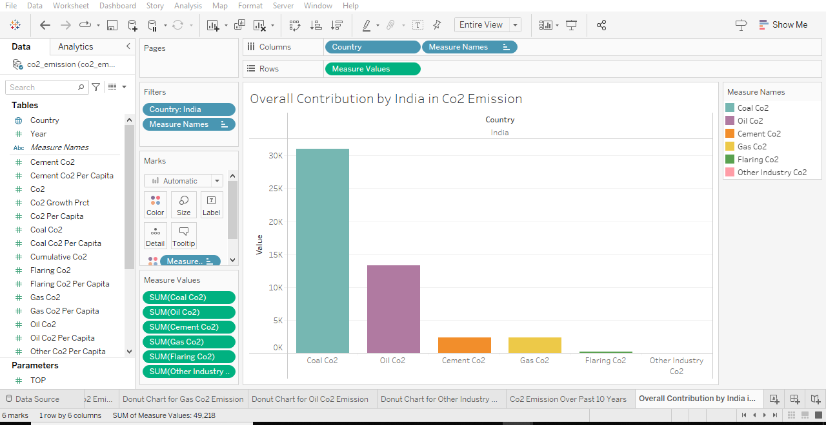

14.CONTINENT WISE CONTRIBUTION BY INTERNAL FACTORS

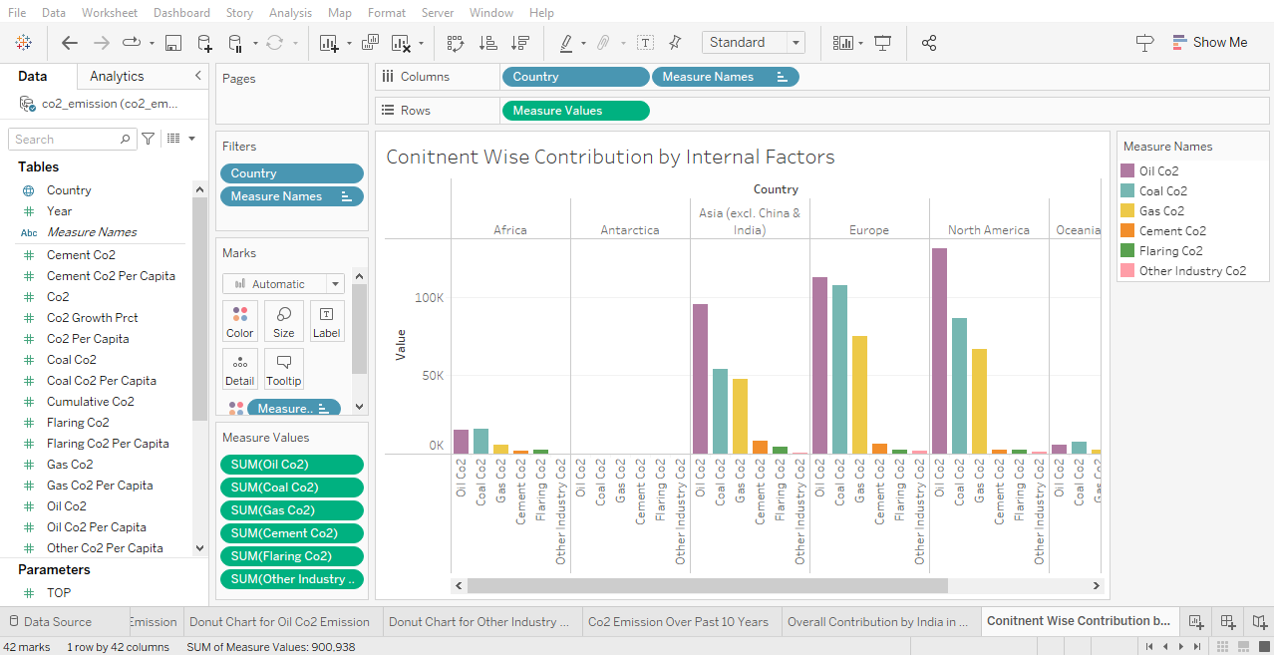

15.CHINA VS INDIA INTERNAL FACTORS

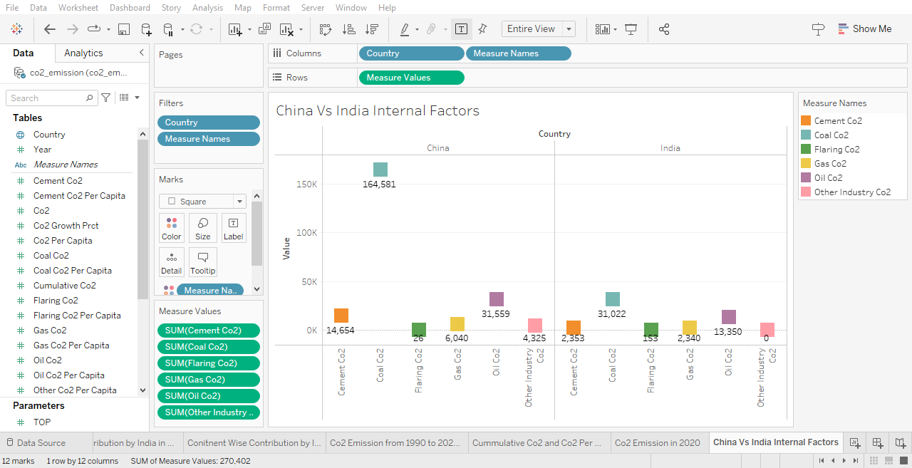

**Dashboard**  
A dashboard is a graphical user interface (GUI) that displays information and data in an organized, easy-to-read format. Dashboards are often used to provide real-time monitoring and analysis of data, and are typically designed for a specific purpose or use case. Dashboards can be used in a variety of settings, such as business, finance, manufacturing, healthcare, and many other industries. They can be used to track key performance indicators (KPIs), monitor performance metrics, and display data in the form of charts, graphs, and tables

DASHBOARD 1

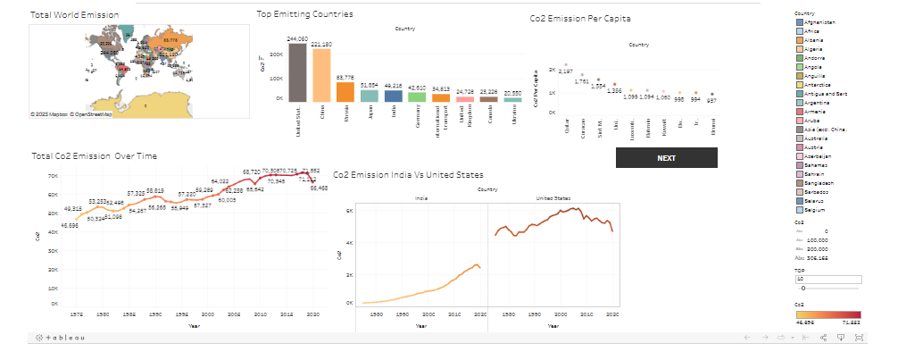

DASHBOARD:2 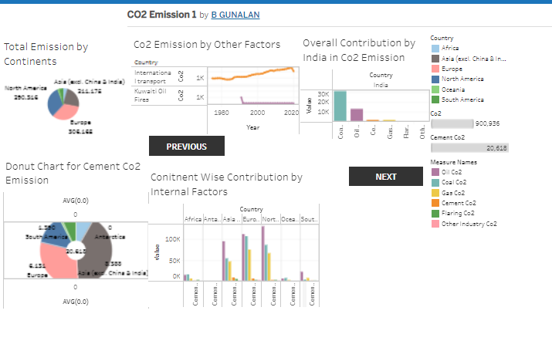

Dashboard :3

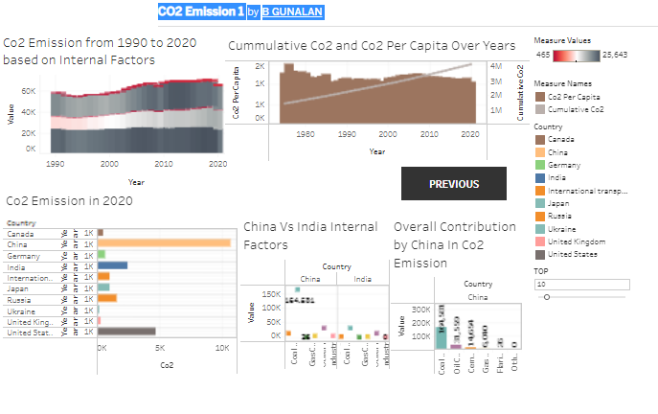

**Story**

A data story is a way of presenting data and analysis in a narrative format, with the goal of making the information more engaging and easier to understand. A data story typically includes a clear introduction that sets the stage and explains the context for the data, a body that presents the data and analysis in a logical and systematic way, and a conclusion that summarizes the key findings and highlights their implications. Data stories can be told using a variety of mediums, such as reports, presentations, interactive visualizations, and videos.* **No of Scenes of Story**The number of scenes in a storyboard for a data visualization analysis of the electricity consumption in india will depend on the complexity of the analysis and the specific insights that are trying to be conveyed. A storyboard is a visual representation of the data analysis process and it breaks down the analysis into a series of steps or scenes.

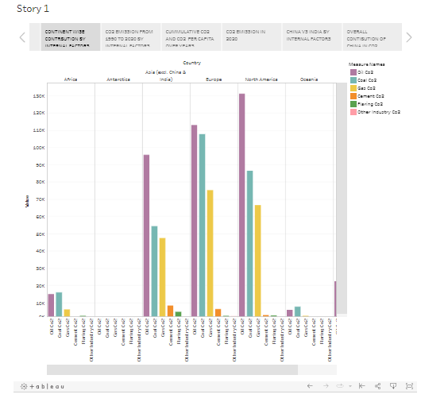

**Performance Testing**

**Amount of Data Rendered To DB  
The amount of the data that is rendered to a database depends on the size of the dataset and the capacity of the database to store and retrieve data. This is schematically represented below.**

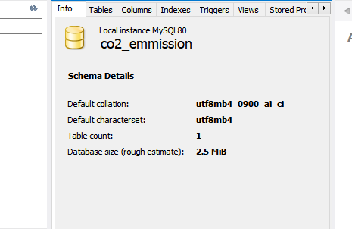

**UTILIZATION OF FILTERS**

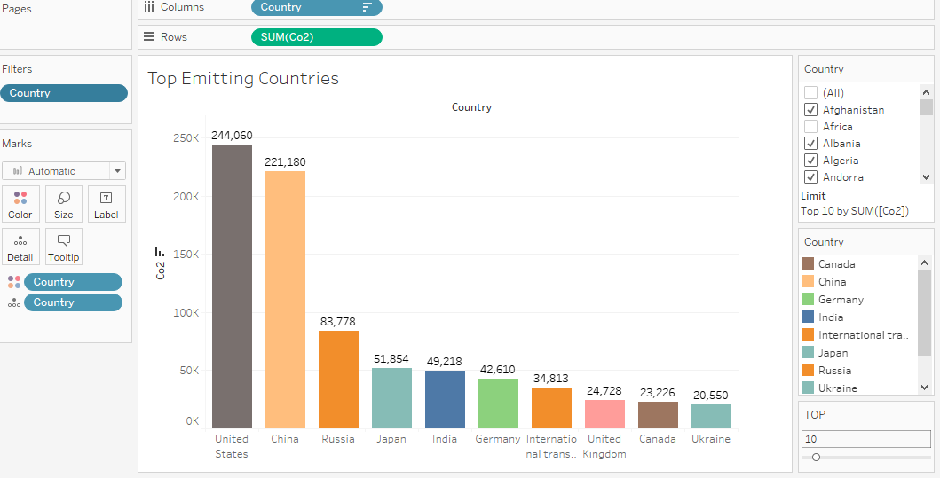

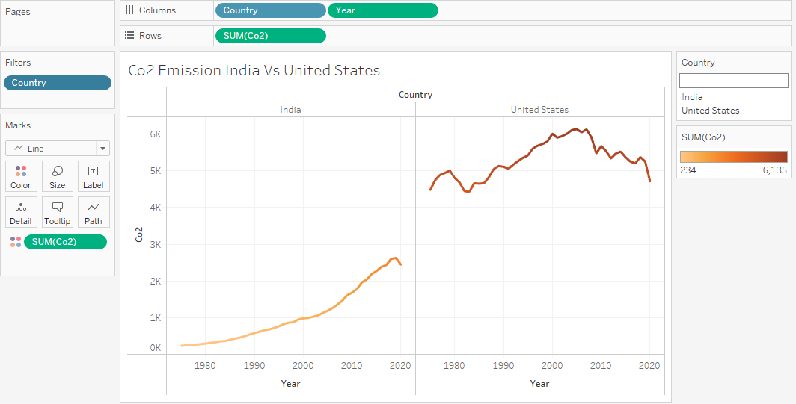

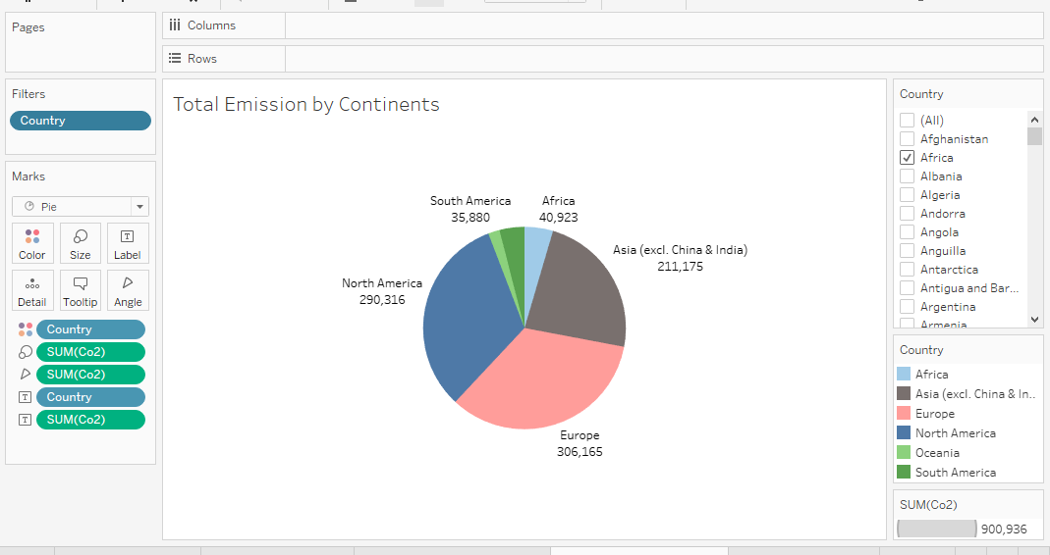

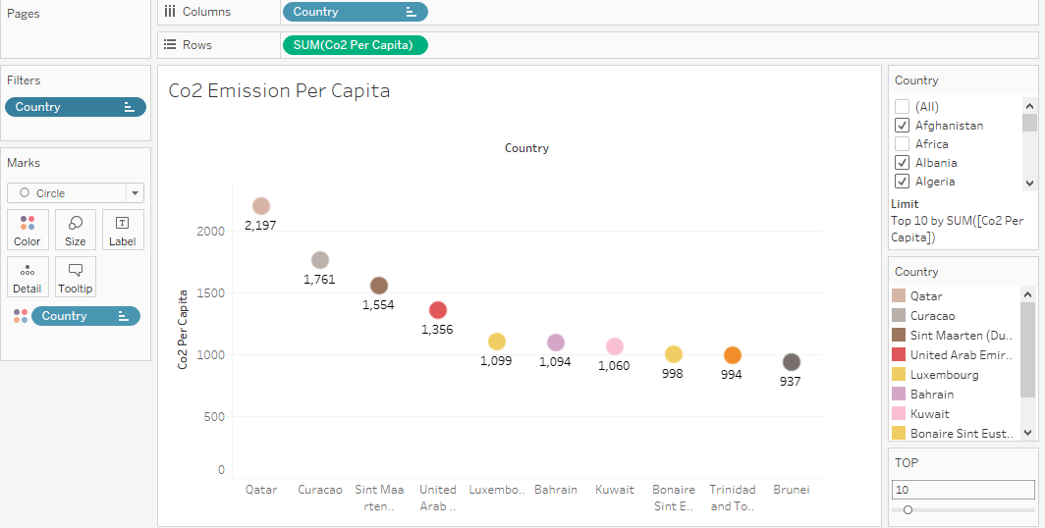

**Publishing dashboard and reports to tableau public**

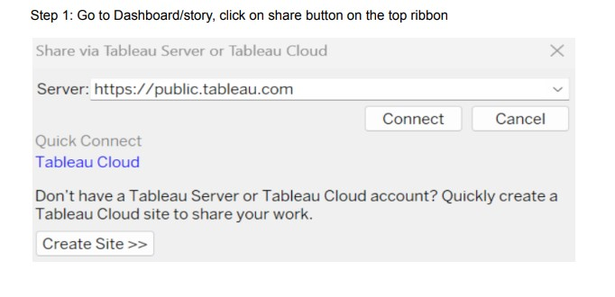

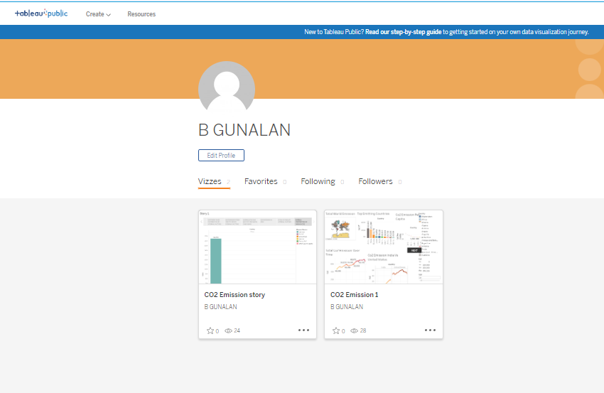

**WEB INTEGRATION**

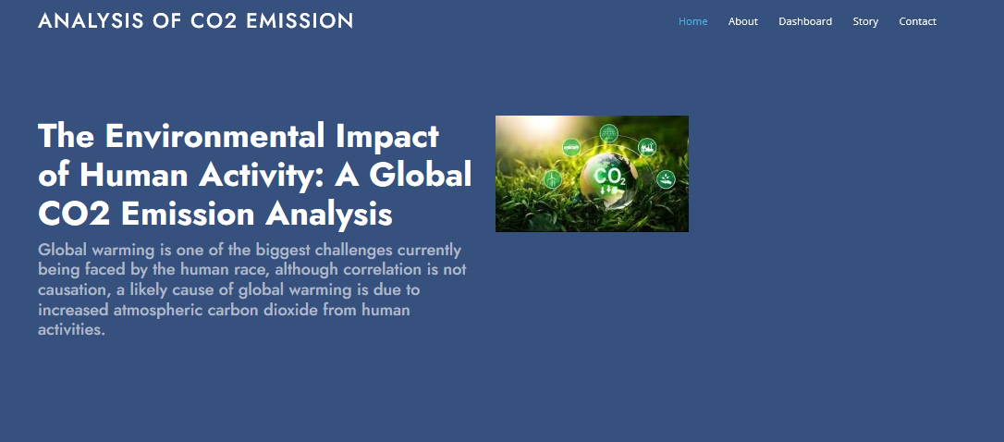

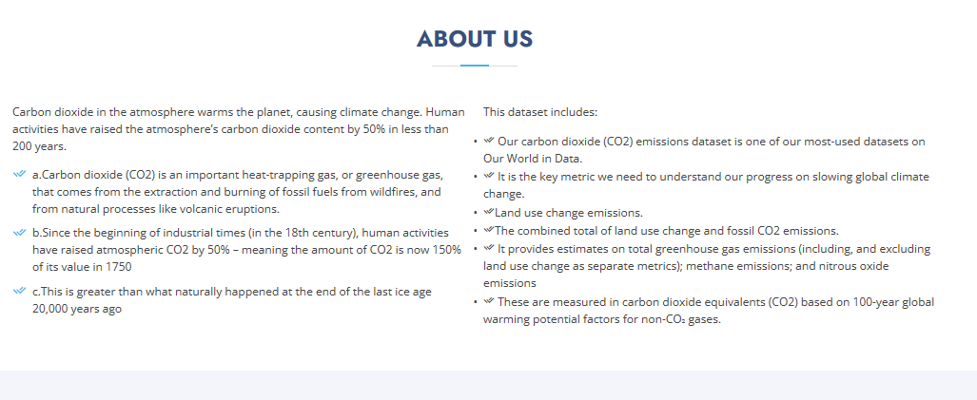

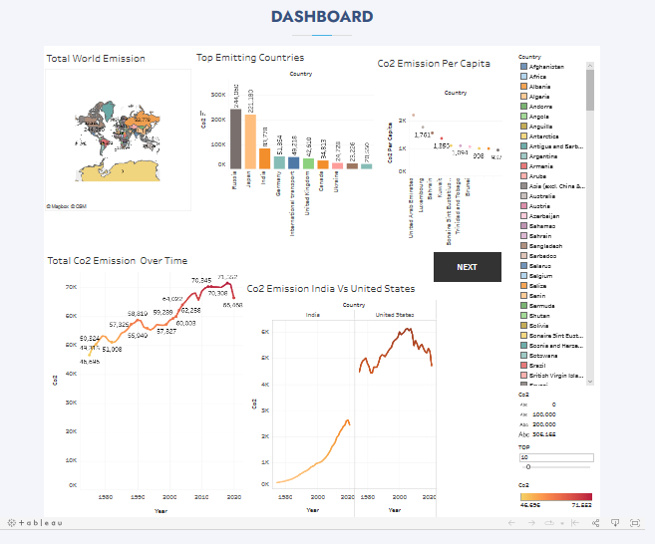

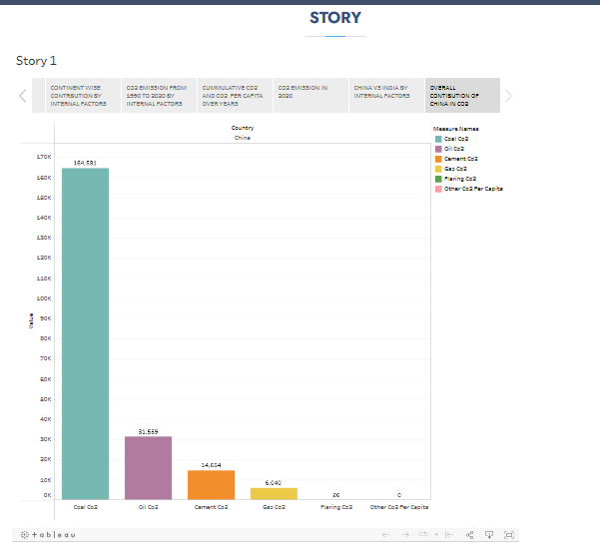

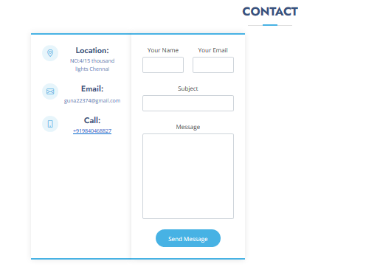

**\*ADVANTAGES AND DISADVANTAGES\***

Green plants grow faster with more CO2. Many also become more drought- resistant because higher CO2 levels allow plants to use water more efficiently. More abundant vegetation from increased CO2 is already apparent.

These may include headaches, dizziness, restlessness, a tingling or pins or needles feeling, difficulty breathing, sweating, tiredness, increased heart rate, elevated blood pressure, coma, asphyxia, and convulsions.

**\*APPLICATIONS\***

Carbon dioxide in solid and in liquid form is used for **refrigeration and cooling**. It is used as an inert gas in chemical processes, in the storage of carbon powder and in fire extinguishers. Metals Industry: Carbon dioxide is used in the manufacture of casting molds to enhance their hardness.

\***FUTURE SCOPE\***

CO2 can also **replace fossil fuels as a raw material in chemicals and polymers**. Less energy-intensive pathways include reacting CO2 with minerals or waste streams, such as iron slag, to form carbonates for building materials. The future market potential for CO2-derived products and services is difficult to assess.

**\*END OF REPORT\***